***Lab 12 – Introduction to PSCPICE***

***Exercise 1***

***Design the given below circuit***

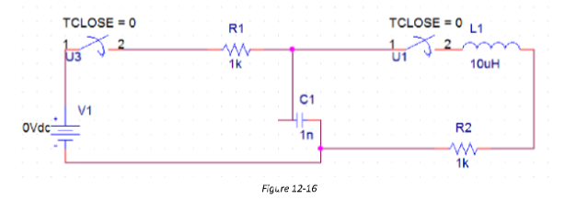

**PSpice Circuit:**

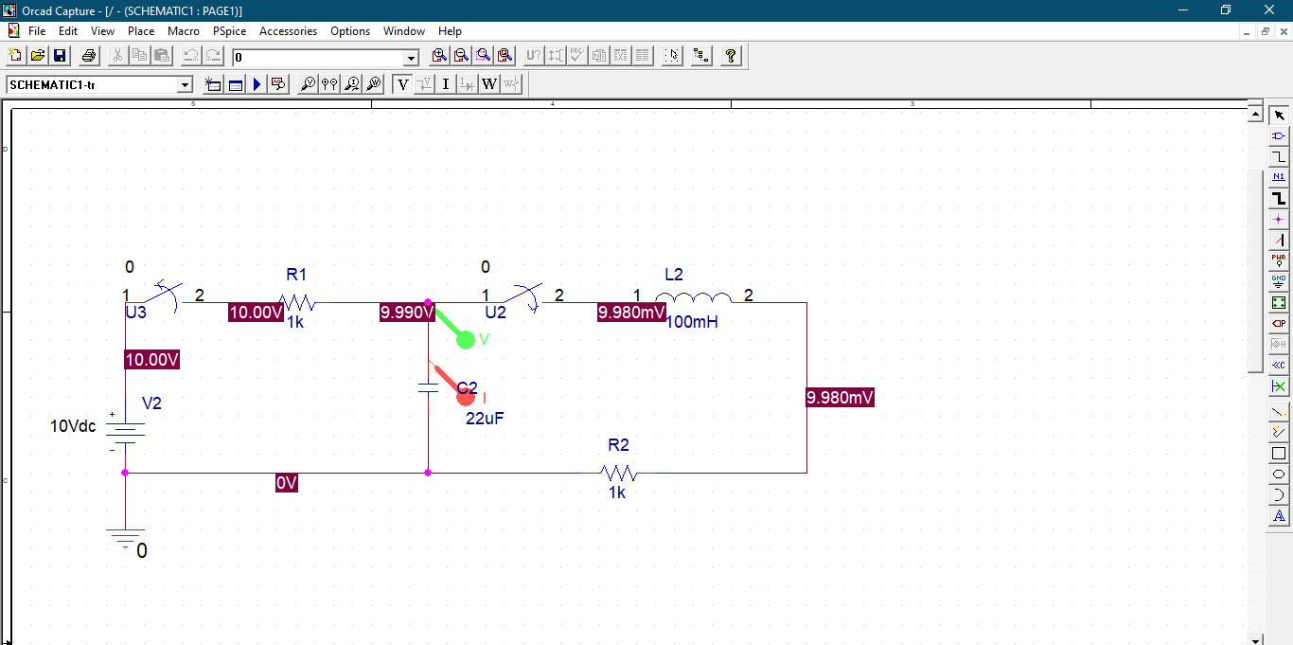

**Output:**

